# CI CD Pipeline on Jenkins

## Problem statement:

Need to implement CI CD pipeline on jenkins as per below instructions –

* Get the project from GIT : <https://github.com/asif-ops/asif-ops.github.io.git>
* Configure jenkins thus it Install the project website from git at slave-1 testing server on docker first, if successful then it should built the project website on slave2-production server.
* Create pipeline view and Trigger the job using git web-hooks , whenever any change at git repository then jenkins should notify it and jenkins will automatically start build process.

## Prescription:

1. Check git repository
2. Install docker at slave nodes
3. Configure build job for Testing server
4. Configure build job for Production server
5. Configure job; after Test job done success it will build Prod job
6. Create Pipeline view to run the job
7. Create Web hook to initiate job when commit has made at GIT repository

## Implementation:

First you need to setup Jenkins Master slave architecture at AWS, how to setup Master slave installation please follow this github link to do the installation **https://github.com/asif-ops/AWS-jenkins-master-slave-setup**

### Check git repository:

https://github.com/asif-ops/asif-ops.github.io.git directory where we can see the website source code and a dockerfile exists as showing below :

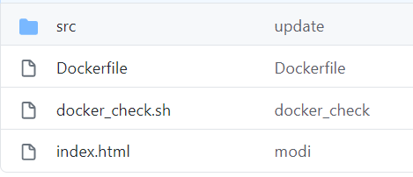

### Install docker at slave nodes:

To install the project on slaves nodes need to install the docker first, run below commands at slave nodes

sudo apt-get update

sudo apt-get install docker.io –y

### Configure build job for Testing server

First create job for testing server, following steps:

**Jenkins GUI dashboard-> Create a job -> Freestyle project -> Enter a item name i.e slave_tesating -> Ok -> GitHub project -> Project URL =** [**https://github.com/asif-ops/asif-ops.github.io.git**](https://github.com/asif-ops/asif-ops.github.io.git) **-> Source Code Management -> Git -> Repository URL = =** [**https://github.com/asif-ops/asif-ops.github.io.git**](https://github.com/asif-ops/asif-ops.github.io.git) **-> Restrict where this project can be run -> Label expression = testing (as this project will run at testing so restricting to testing server only by this option) -> Save -> So now we can check connections status between jenkins master and slave**

Below is the screenshot of the important steps below

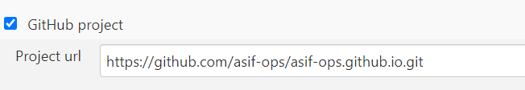

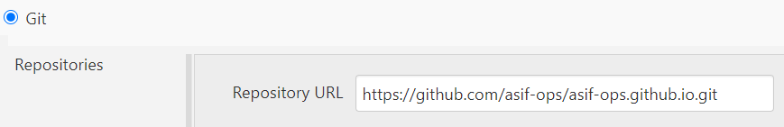

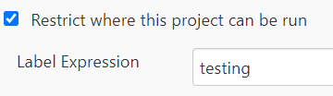

Now click on “Build Now” and check whether build step success or not , if the build button show blue color then build step is success

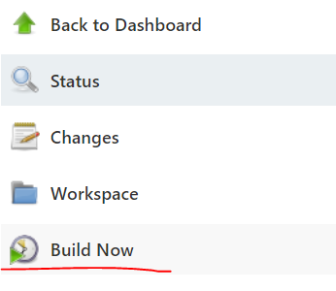

After build now we see that build process is successful as build process is showing blue color



Now login to testing server and check that whether build step is success or not. We see that at under /home/ubuntu/jenkins/workspace/testing_slave our remote git repository is created as showing below :

**ubuntu@ip-172-31-12-142:~/jenkins/workspace/testing_slave$ pwd**

**/home/ubuntu/jenkins/workspace/testing_slave**

**ubuntu@ip-172-31-12-142:~/jenkins/workspace/testing_slave$ ls**

**Dockerfile docker_check.sh index.html src**

if I go to workspace of testing sever at jenkins GUI then it also shows content of the git repository . So that means from our master Jenkins we can successfully can connect to our slave node and apply job successfully

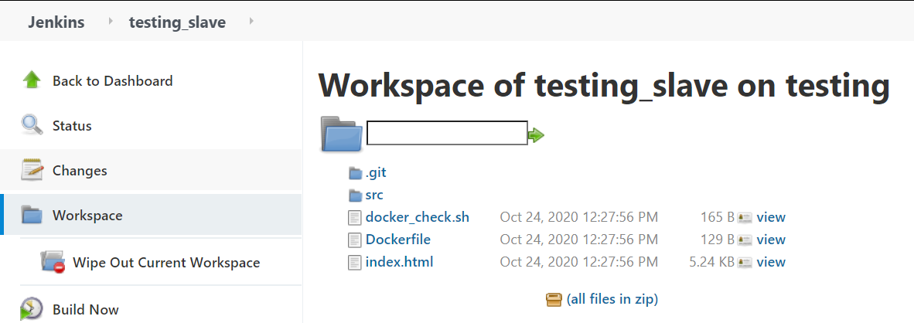

Now go back to configure the build job

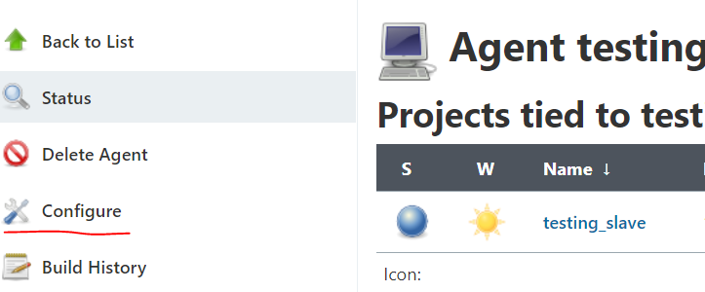

**Build -> Execute shell**

Execute shell will basically run shell commands that need to run to perform the build step

**#this will make this script file executable. function of this script**

**#file is to rm any running container from the testing server if exists**

**sudo chmod +x docker_check.sh**

**sudo ./docker_check.sh > /home/ubuntu/jenkins/output.txt**

**#docker buid**

**sudo docker build . -t web**

**#docker run the website on port 82**

**sudo docker run -it -d -p 82:80 web**

**#check docker process**

**sudo docker ps**

**#then check website on localhost on port 82**

**sudo curl localhost:82**

**Configure -> Build -> Execute shell**

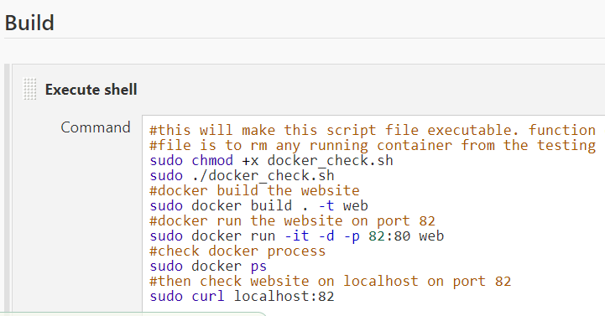

Now “Save” . Our job now has saved and next thing we need to do lets go ahead and run this job .Lets go to jenkins dash board and run “Build Now”

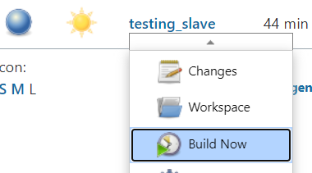

Now we see the build process is success for this step



Also we can see the console output of this build process for the log if there is any error

Finally we can browse the website at instance public IP at por t82 to see the website content as showing bellow . this is the project website , which tested at testing sever successfully

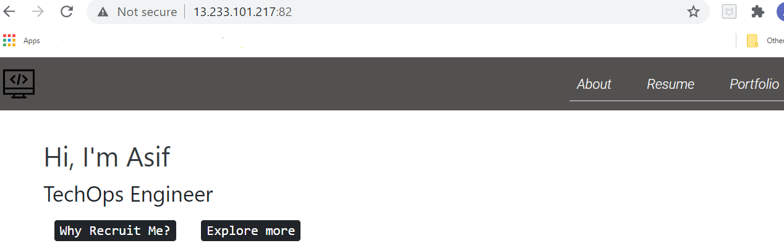

### Configure build job for Production server

Now configure the Production server build job same like Testing server as per below steps:

Jenkins GUI dashboard -> Free style project -> New Item -> Enter an item name: Prodcuction server -> **Jenkins GUI dashboard-> Create a job -> Freestyle project -> Enter a item name i.e slave_tesating -> Ok -> GitHub project -> Project URL =** [**https://github.com/asif-ops/asif-ops.github.io.git**](https://github.com/asif-ops/asif-ops.github.io.git) **-> Source Code Management -> Git -> Repository URL = =** [**https://github.com/asif-ops/asif-ops.github.io.git**](https://github.com/asif-ops/asif-ops.github.io.git) **-> Restrict where this project can be run -> Label expression = production (as this project will run at production so restricting to production server only by this option) -> Build Step -> Execute shell commands (here use the same commands as testing server ) -> Save -> Run the build step and verify whether the production server has deploy the project successfully or not**

Execute shell will basically run shell commands that need to run to perform the build step

**#this will make this script file executable. function of this script**

**#file is to rm any running container from the testing server if exists**

**sudo chmod +x docker_check.sh**

**sudo ./docker_check.sh > /home/ubuntu/jenkins/output.txt**

**#docker buid**

**sudo docker build . -t web**

**#docker run the website on port 82**

**sudo docker run -it -d -p 82:80 web**

**#check docker process**

**sudo docker ps**

**#then check website on localhost on port 82**

**sudo curl localhost:82**

**Now we see the build project, found that build job is running successfully**



Now we can browse the production server public IP at port and can see the website contents as showing below picture. Now testing is successfully at both production and testing server

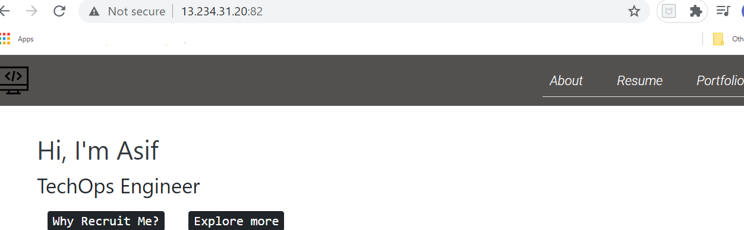

### Configure job; after Test job done success it will build Prod job

To do that Jenkins GUI -> testing server -> Configure -> Post-build Actions -> Select “Build other projects” from dropdown -> Projects to build = Prodcuction server -> Trigger only build is stable

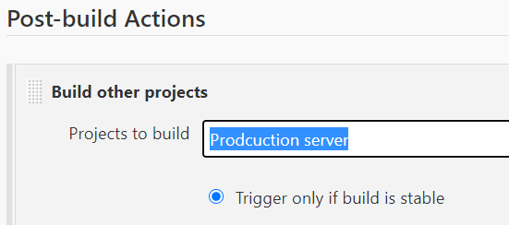

Now test the build process by build now on testing serve “Builld now”. After test we found that build process for testing server and after that build job production is also successful

Testing server build job 

Production server build job 

Browse production server ip on port 82 and found that project is website is successful l.

### Create Pipeline view to run the job

First install the pipeline plugin by:

Jenkins GUI dashboard -> Manage jenkins -> Manage plugins -> Availavble -> search “build pipeline” -> [Build Pipeline](https://plugins.jenkins.io/build-pipeline-plugin) -> Install without restart

Now start create build pipeline view

Jenkins GUI dashboard -> click + sign -> select “Build pipeline view” -> just give a view name -> ok -> Select initial Job = Testing server -> OK



Then finally Build view will look like below

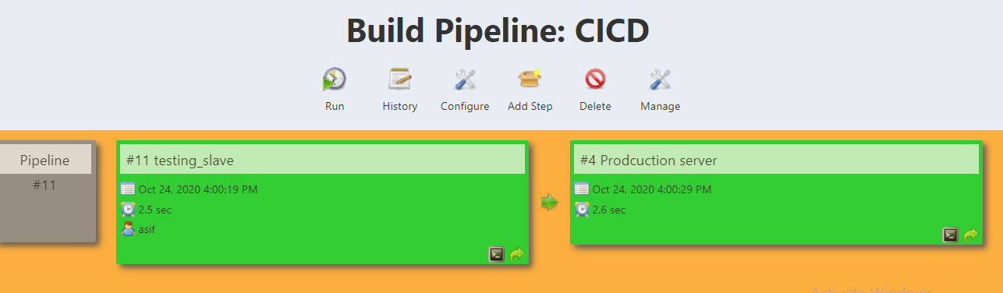

Now click on “run” on same page and we found that Buile pipeline CICD has run successfully at slave node first and then it run the build at production node as showing below

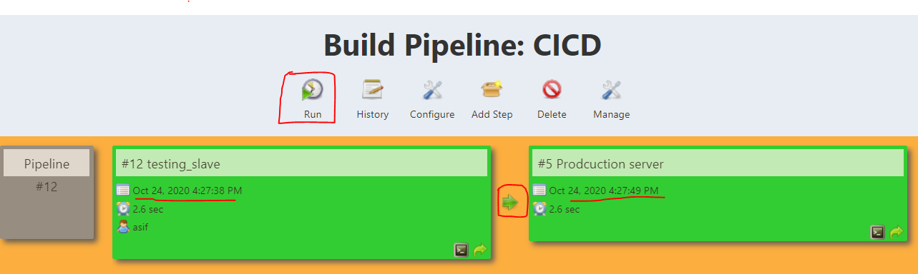

### Create Web hook to initiate job when commit has made at GIT repository

Jenkins GUI dashboard -> Testing server -> Configure -> Build Triggers -> GitHub hook trigger for GITScm polling -> Save

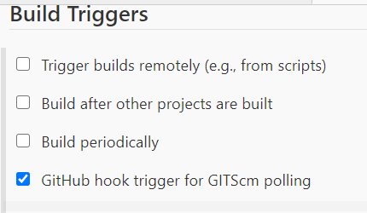

Now go to github repository -> settings -> Webhooks -> Add Webhook -> **Payload URL = Your jenkins server IP:port -** **github-webhook/ (in this case http://13.232.199.239:8080/github-webhook/) > Add webhook**

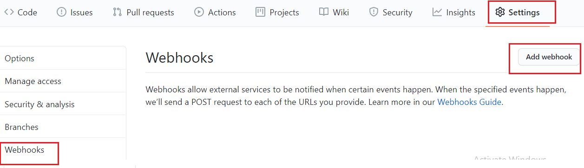

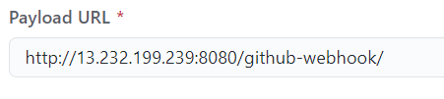

Then if everything working fine then it will show you a tick mark as show below

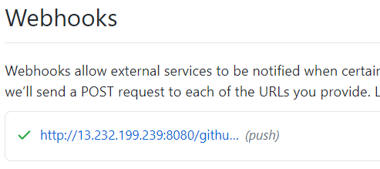

Now commit some changes to your Git hub repository. In this case I did some change at index.html file and push the change to git hub . now as soon new code has been pushed to github then jenkins build starts job and job done successfully

Git hub updated:



Jenkins do new build job:

